Test: I can navigate through each page successfully.

Given I am on the Holiday Application Home page

And I enter a continent

And I Click the submit button

Then I should navigate to the next page:

*Given I am on the application page*

*And I enter a continent*

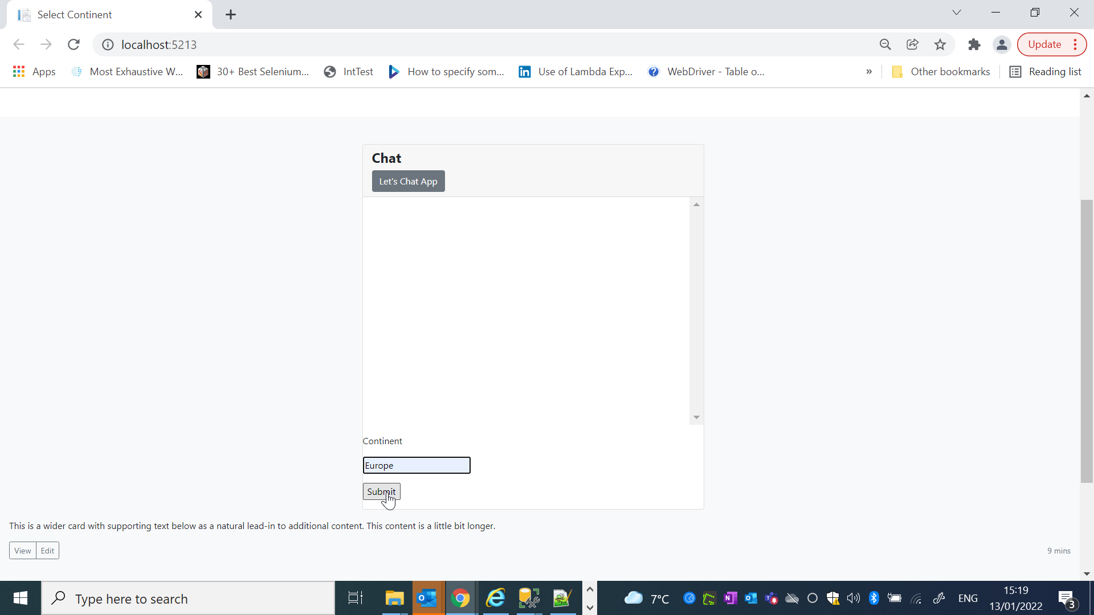

*And I click the submit button*

*Then I navigate to the next page.*

Test Passed

Test 2

Given I am on the Holiday Application Home page

And I enter a ‘Europe’ as the continent

And I enter a ‘active’ as the category

And I enter a ‘mild as the temp rating

And I enter a ‘active’ as the category

Then I should see the results for :

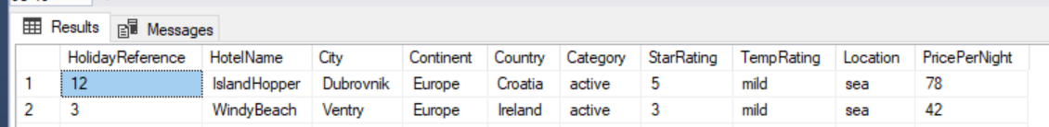

*Given I am on the Holiday Application Home page*

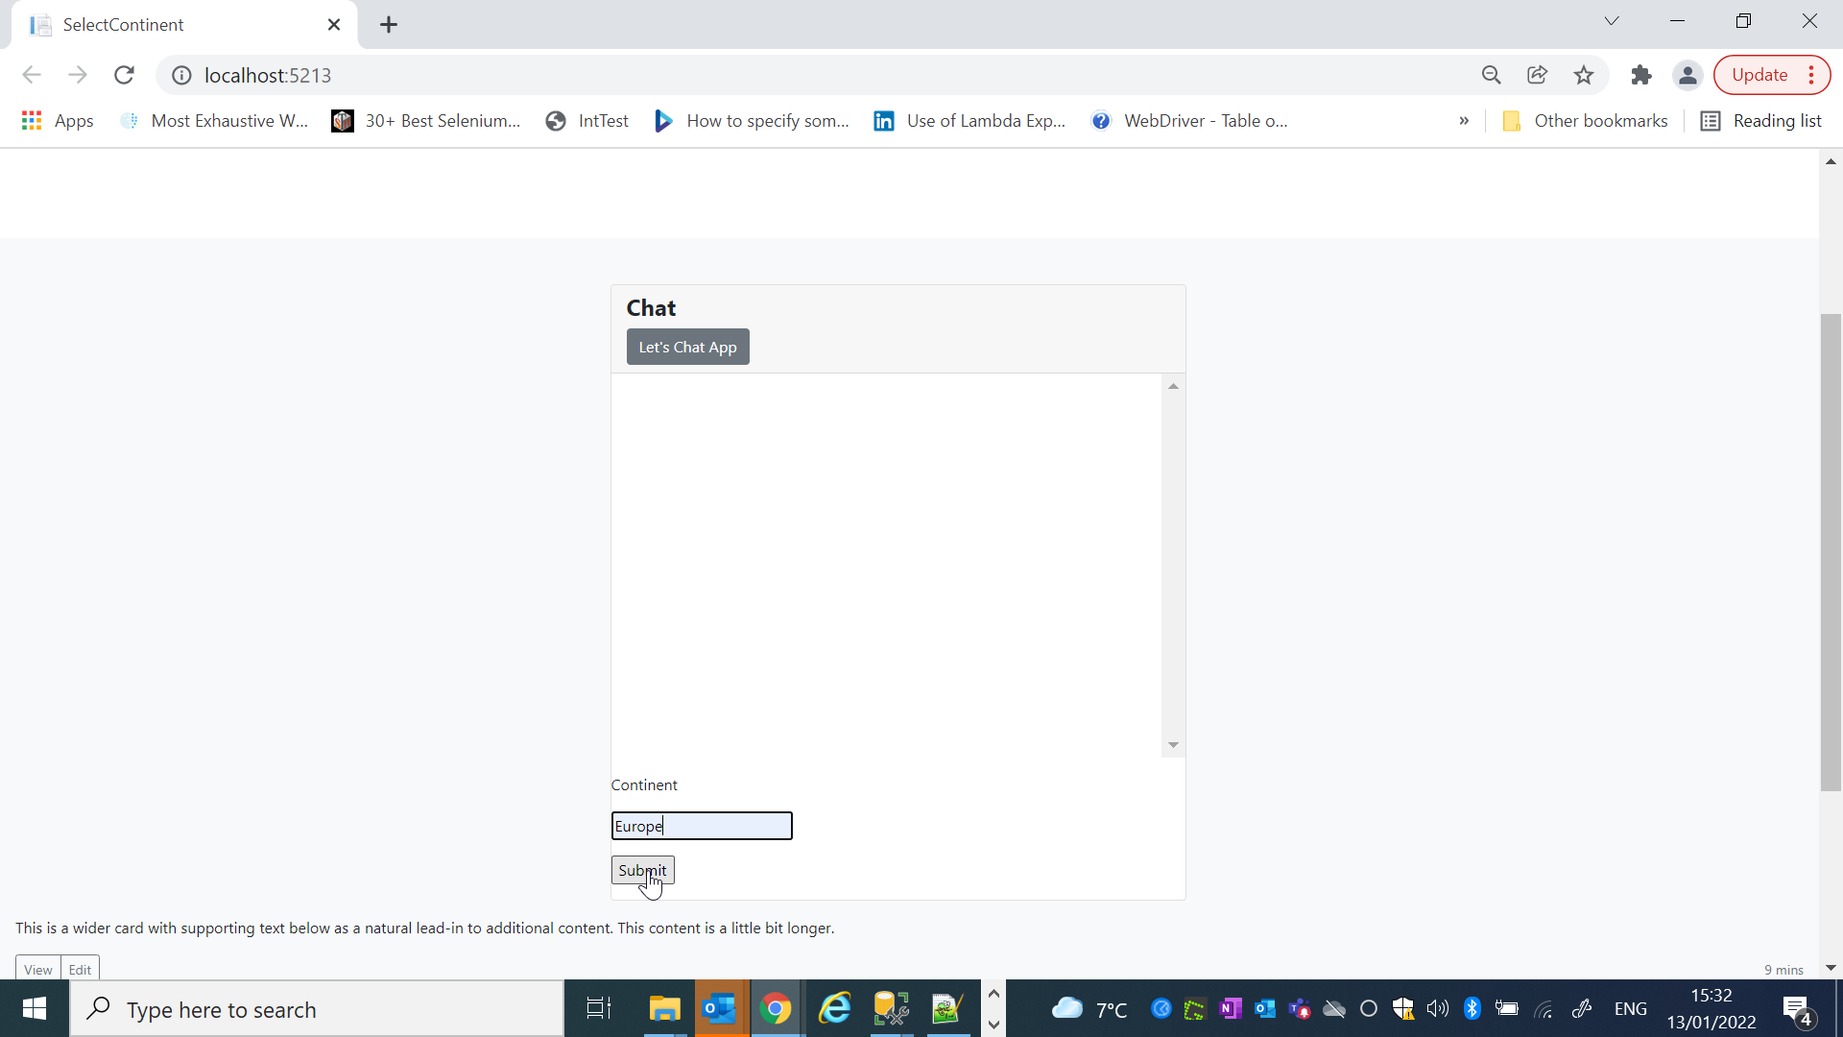

*And I enter a ‘Europe’ as the continent*

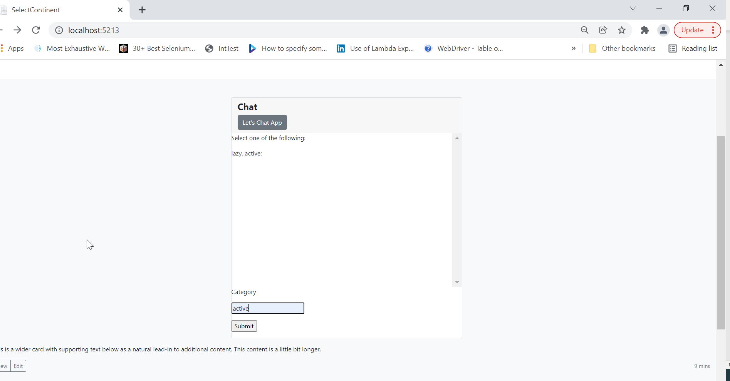

*And I enter a ‘active’ as the category*

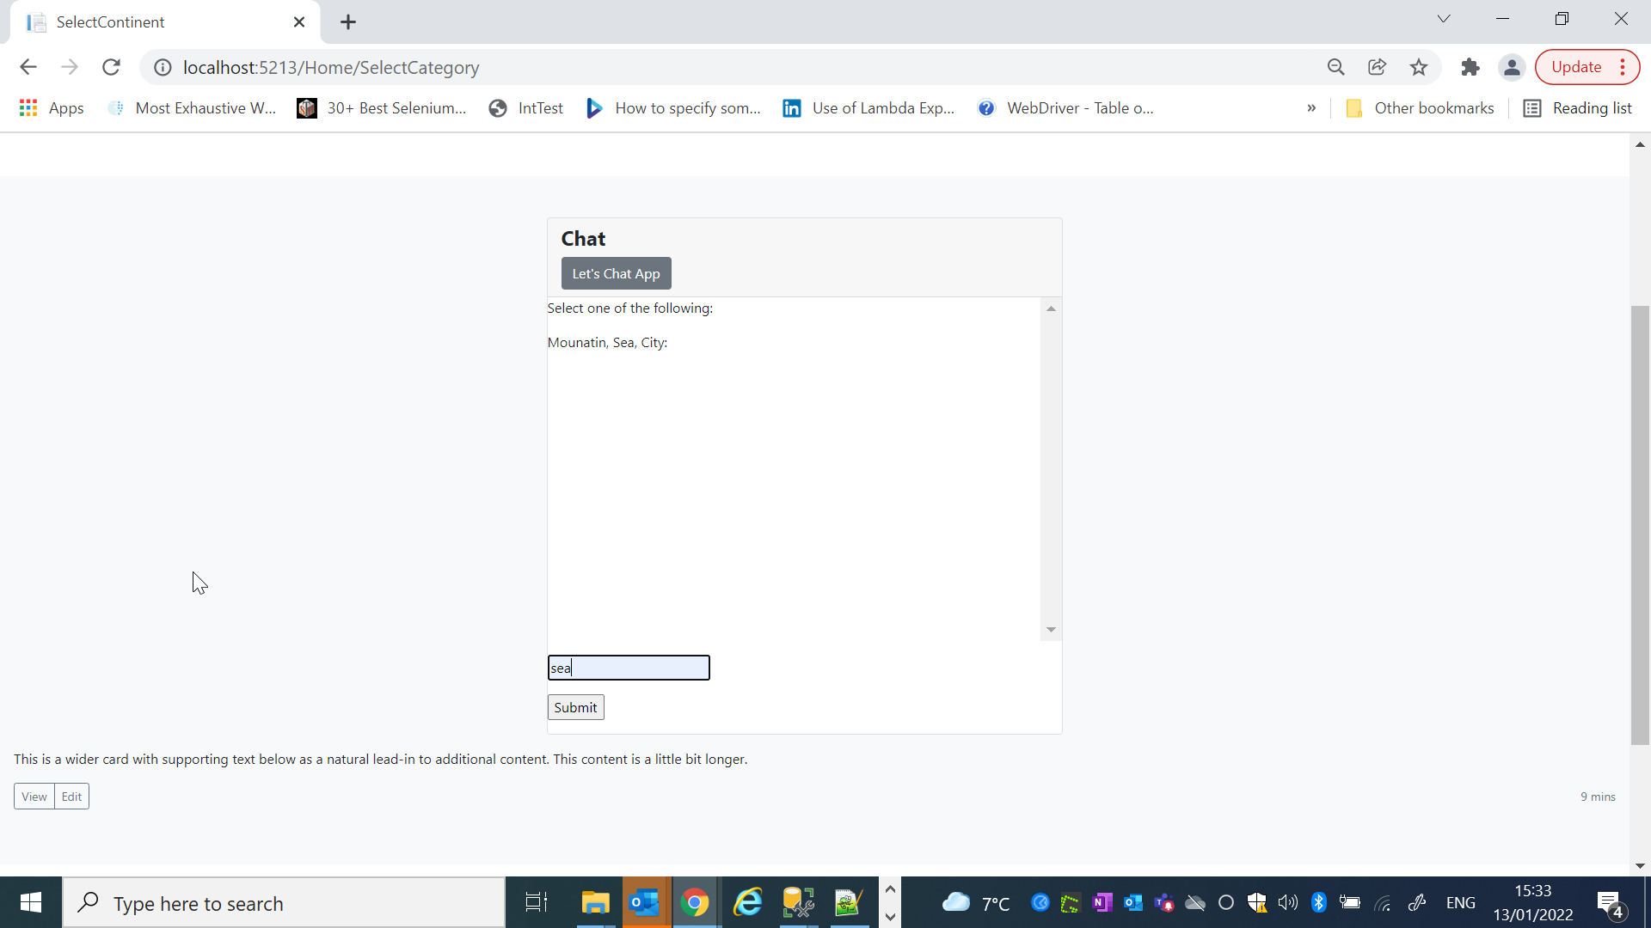

*And I enter a ‘mild as the temp rating*

s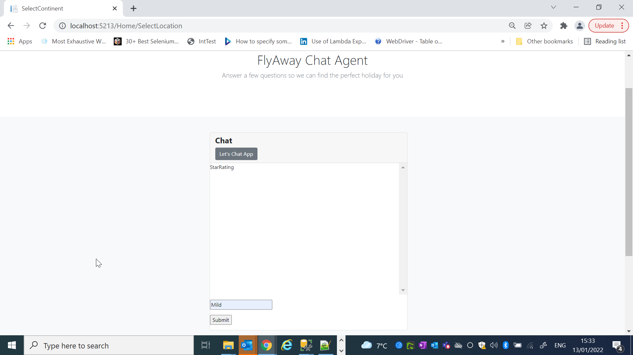

*And I enter a ‘active’ as the category*

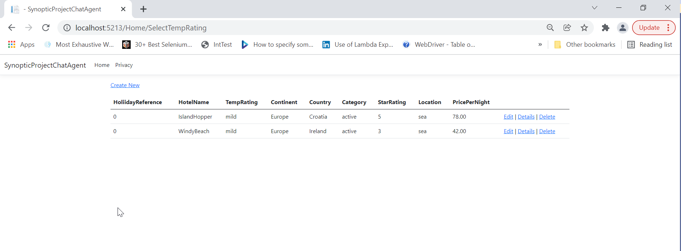

Then I should see the results for :

